|  |  |  |
| --- | --- | --- |
| **Last modified by** | **Date** | **Reason** |
| Jeremy | 10/17/2016 | Created SOP |
|  |  |  |
|  |  |  |

Created by/Owner: Jeremy Deel

Table of Contents

Purpose of SOP: 2

Scope/Timing: 2

Responsibility: 2

Materials/Tools needed: 2

Related Document(s): 2

Pre Requisites: 2

Processing Steps: 3

Conclusion: 4

# Purpose of SOP: Copy a standard report

# Scope/Timing: 30-60 Minutes

# Responsibility: N/A

# Materials/Tools needed: WD

# Related Document(s): N/A

# Pre Requisites: Report writing access is required

# Processing Steps:

1. Type the name of the report you want to copy in the Search box and press **Enter**.

2. Run the report and then select the **Related Action menu/Standard Report/Copy**.

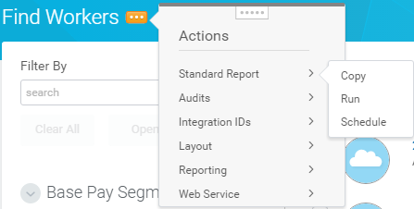

3. Rename the report to something you can remember for example add your initials. Do not check the temporary box UNLESS you only need the report for a certain time period.

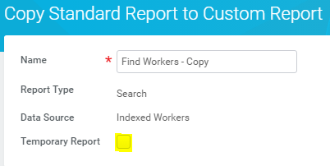

4. You can now modify the report columns.



When editing a custom report, you can modify the fields that will be displayed as columns in the report via the Columns tab.

* Use the + and – icons to add or remove a row.
* Use the up and down arrows to reorder the rows.
* Select the field you want to display.
* Optionally, override the field name displayed on the report.
* Select from a variety of numeric formats (masks).
* Select options for how the data should be displayed.

5. Make sure to test your report prior to running it. By doing this you can catch any errors and it uses a much smaller population.

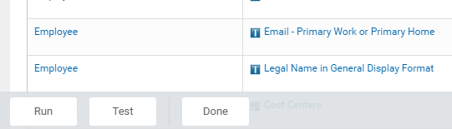

# Conclusion:

**You will be the only person who can view and run this report. If you want another person to gain access you will have to provide them permission.**



 